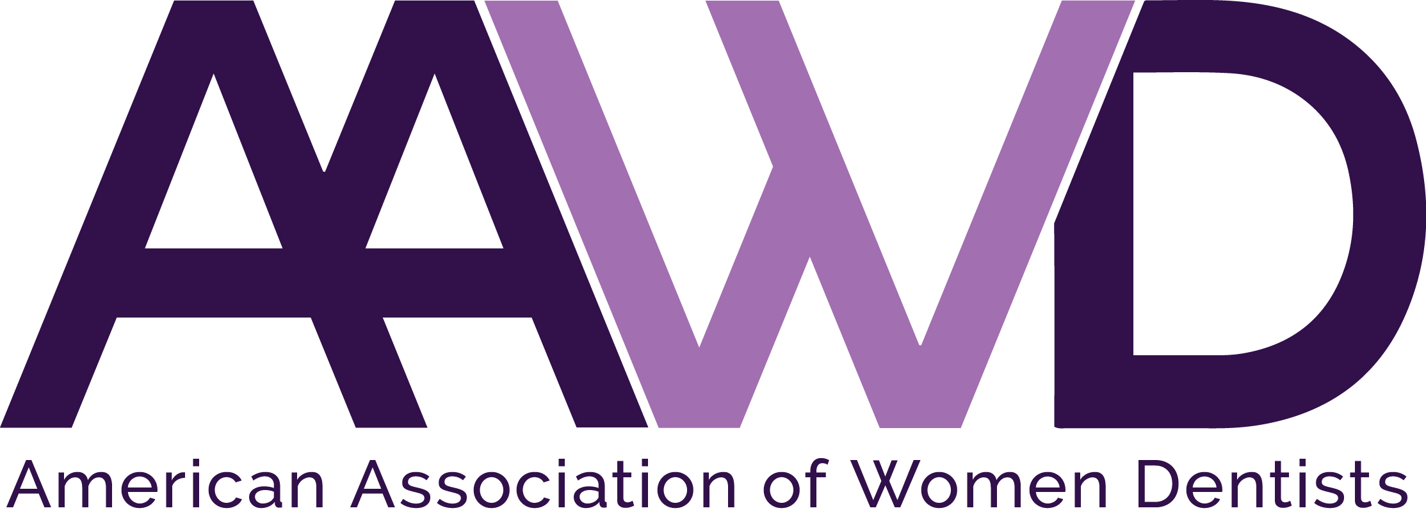

2017 Federal Services Award

The American Association of Women Dentists presents the Federal Services Award to recognize the lifetime achievements made by women dentists in the Federal Services arena. Application instructions for this award are listed below.

Each year AAWD presents the Federal Services Award to a woman dentist who:
• Has made outstanding achievements in the Federal Services arena as an advocate or
dental officer
• Exhibits role model qualities that positively reflect the image of women dentists
and commitment to the profession

To nominate an AAWD member deserving of this award, complete the nomination form below and return it to the AAWD National Office, along with a recommendation letter detailing why the nominee should be selected as well as their curriculum vitae. Please forward this information to the AAWD National Office no later than: August 1, 2017.

Nominee eligibility requirements:
• Current AAWD member in good standing and history of full membership in
AAWD
- Service as a Federal Service dental officer OR acting as an advocate for women Federal Service dental officers
- Nominee must not have been a member of the AAWD board during the past two (2) calendar years

Nominator must submit the following:
- Application form
- Nominee’s curriculum vitae
- Letter of recommendation on behalf of nominee, explaining reasons for nomination including mentoring and advocacy efforts

The recipient will be selected by Federal Services representatives and the award will be presented in September, 2017 during AAWD’s Annual Meeting at Amelia Island, FL.

If you have any questions, please call the AAWD National Office at 1-800-920-2293.

FEDERAL SERVICES AWARD APPLICATION

Please fill out all information completely and legibly. Please print or type.

Nominator Name: __________________________________________________________

Nominator Address: ________________________________________________________

Nominator City, State, Zip: __________________________________________________

Nominee Name: ___________________________________________________________

Nominee Address: _________________________________________________________

Nominee City, State, Zip: ___________________________________________________

Nominee Telephone: _______________________________________________________

Nominee E-mail address: ____________________________________________________

Your completed application should consist of:
- This application form as the first part of your packet
- Nominator’s typed letter of recommendation explaining reasons for nomination (include information pertaining to nominee’s mentoring and advocacy efforts)
- Copy of nominee’s current CV

Mail completed application by August 1, 2017 to:
American Association of Women Dentists
National Office
7794 Grow Drive
Pensacola, FL 32514

E-mail: april.edwards@aawd.org
Fax : 850-484-8762

The Mission of the American Association of Women Dentist:
To be the leading resource for advancing, connecting, and enriching the lives of women dentists.

