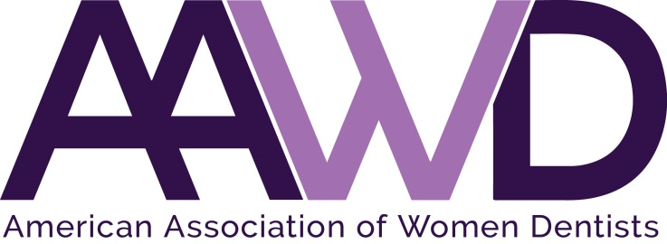

2018 Eleanor J. Bushee Senior Dental Student Award

The American Association of Women Dentists presents the Eleanor J. Bushee Senior Dental Student Award each year to honor senior dental students who have achieved academic excellence and have demonstrated outstanding leadership. We have enclosed an Eleanor Bushee Senior Dental Student Award application. Information, guidelines, and the deadline date are listed below.

Dr. Bushee graduated from Northwestern Dental School in 1944. After 15 years in private practice, she entered the academic world. She attained the position of Professor of Pediatric Dentistry and Orthodontics as well as Assistant Dean for Administration at Southern Illinois University of Dental Medicine. Dr. Bushee was an accomplished author and lecturer. She lived her life with verve and style. The recipient of this award should demonstrate enthusiasm in her career in dentistry and in her life as a colleague, friend and mentor.

An advisor or dean must recommend that a senior dental student receive the award. Once the application is completed, allow two to three weeks for the certificate to arrive by mail. This award will be accompanied by a one-year complimentary membership in the American Association of Women Dentists.

The deadline for return of materials is March 9, 2018. Please fax materials to 850-484-8762 or e-mail to awards@aawd.org.

Thank you in advance for submitting an outstanding senior dental student for this honor and award.

Sincerely,
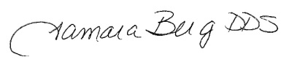
Dr. Tamara Berg
AAWD President, 2018

ELEANOR BUSHEE SENIOR DENTAL STUDENT
2018 AWARD APPLICATION

The following graduating dental student has been nominated for the 2018 Eleanor J. Bushee Senior Student Dental Award for academic excellence and outstanding leadership:
Please fill out all information completely and legibly. Please print or type.
School: ______________________________________________________________________________
Award to be presented to: ____________________________________________________________________________
Name as it should appear on certificate: ____________________________________________________________________________
Advisor recommending the award: ____________________________________________________________________________
Send correspondence to: ____________________________________________________________________________
Address: ____________________________________________________________________________
City, State, Zip: ____________________________________________________________________________
Telephone: _____________________________________________________________________________
Date of award: _____________________________________________________________________________
Reason why student was selected: __________________________________________________________________________________________________________________________________________________________________________________________________________________________________________________________________________________________________________________________________________________________________________________________________________________________________________________________________________________________________________________________________________________________________
ELEANOR BUSHEE SENIOR DENTAL STUDENT AWARD APPLICATION

Please return no later than March 9, 2018.

Return form to:
American Association of Women Dentists
National Office
7794 Grow Drive
Pensacola, FL 32514
Email: awards@aawd.org
Fax: 850-484-8762

If you have any questions, please call 800-920-2293.

Please allow two to three weeks for processing of certificate.

Thank you for your participation in this program.

The Mission of the American Association of Women Dentist:
“To be the leading resource for advancing, connecting, and enriching
the lives of women dentists"

