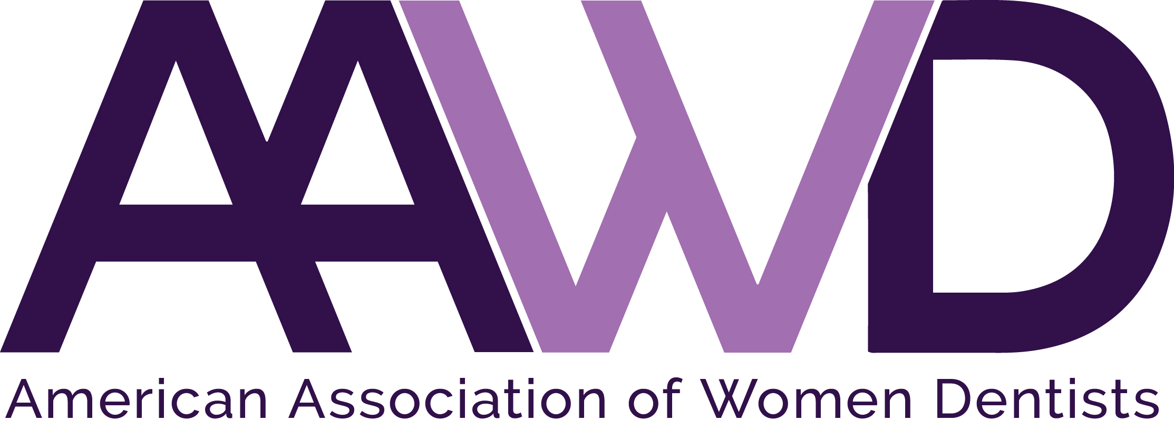

2018 Federal Services Award

The American Association of Women Dentists presents the 2018 Federal Services Award to recognize the lifetime achievements made by women dentists in the Federal Services arena. Application instructions for this award are listed below.

Each year AAWD accepts Federal Services Award nominations for a woman dentist who:
• Has made outstanding achievements in the Federal Services arena as an advocate or
dental officer.
• Exhibits role model qualities that positively reflect the image of women dentists
and commitment to the profession.

To nominate an AAWD member deserving of this award, complete the nomination form following and return it to the AAWD National Office, along with a recommendation letter detailing why the nominee should be selected, as well as the nominee’s curriculum vitae.

Please forward this information to the AAWD National Office no later than: July 1, 2018.

Nominee eligibility requirements:
• Current AAWD member in good standing and history of full membership in
AAWD.
- Service as a Federal Service dental officer OR acting as an advocate for women Federal Service dental officers.
- Nominee must not have been a member of the AAWD board during the past two calendar years.

Nominator must submit the following:
- Application form.
- Nominee’s curriculum vitae.
- Letter of recommendation on behalf of nominee, explaining reasons for nomination including mentoring and advocacy efforts.

The recipient will be selected by AAWD’s Federal Services representatives, and the award will be presented October 6, 2018, during AAWD’s Annual Conference in Savannah, Georgia.

If you have any questions, please call the AAWD National Office at 1-800-920-2293.
AAWD 2018 FEDERAL SERVICES AWARD APPLICATION

Please fill out all information completely and legibly.

Nominator’s Name: _____________________________________________________________

Nominator’s Address: ___________________________________________________________

Nominator’s City, State, Zip: _____________________________________________________

Nominator’s Telephone: _________________________________________________________

Nominee’s Name: ______________________________________________________________

Nominee’s Address: ____________________________________________________________

Nominee’s City, State, Zip: ______________________________________________________

Nominee’s Telephone: __________________________________________________________

Nominee’s Email Address: _______________________________________________________

Your completed application should consist of:
- This application form as the first part of your packet.
- Nominator’s typed letter of recommendation explaining reasons for nomination (include information pertaining to nominee’s mentoring and advocacy efforts).
- Copy of nominee’s current CV.

Completed applications must be received by AAWD National Office by July 1, 2018.

Email: awards@aawd.org
Fax: 850-484-8762
Mail: American Association of Women Dentists
National Office
7794 Grow Drive
Pensacola, FL 32514-7072

The Mission of the American Association of Women Dentist:
To be the leading resource for advancing, connecting, and enriching the lives of women dentists.

