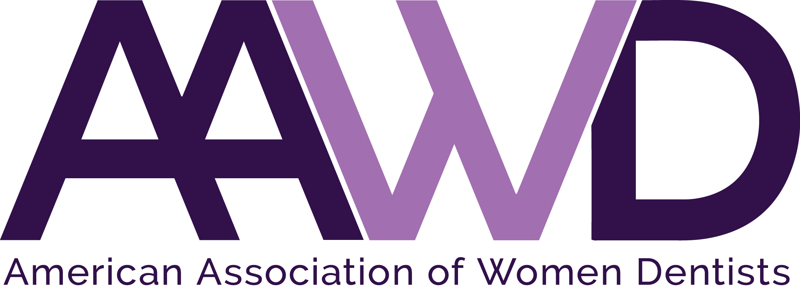

2018 Lucy Hobbs Taylor Award Nomination

In 1859 Lucy Hobbs Taylor moved to Cincinnati, intent on attending medical school. After being refused admission based on her gender, Taylor studied privately under a professor who encouraged her to turn to dentistry.

Following her studies in dentistry, Lucy started her own practice in Cincinnati. Finally in 1865, she gained professional recognition when she was elected to membership of the Iowa State Dental Society and served as a delegate at the American Dental Association convention in Chicago, Illinois. That November, she was admitted to the Ohio College of Dental Surgery, where she became the first woman to earn a doctorate in dentistry.

In her honor, each year AAWD presents the Lucy Hobbs Taylor Award to a woman dentist who:

- Is a willing example of a true professional and one who has a record of accomplishment in one or more areas of dentistry [for example, clinical dentistry (including fields of specialization), organized dentistry, academia, government, anthropology, archeology, philanthropy (includes community involvement), and consulting (for example, to the insurance industry)].
- Has a record of at least 10 years membership in AAWD to include current membership (as verified by AAWD). (The AAWD membership must be stated on the resumé with the exact years being claimed. AAWD Board of Directors are not eligible for the LHT Award unless it has been two years since they served on the AAWD Board of Directors.)
- Has had a career as a licensed dentist for at least 20 years as stated on the resumé to include jurisdiction and the exact years being claimed.
- Has a record of mentoring women dentists and/or service to organizations that further the cause of women in dentistry.
The Lucy Hobbs Taylor Award is the highest award given by our organization. It will be presented October 6, 2018, during the AAWD 97th Annual Conference in Savannah, Georgia.

To nominate an AAWD member deserving of this award, complete the nomination form below and return it to the AAWD National Office by June 1, 2018, along with a cover letter detailing why the nominee should be selected and their resume or curriculum vitae.
---------------------------------------------------------------------------------------------------------------------------------------------------------

Nominee’s name: ________________________________________________________________________________

Nominated by: __________________________________________________________________________________

Nominator’s signature____________________________________________________________________________

Do you certify that you are at least 18 years of age? Yes ________ No ________

Your completed application should consist of:
• This application as the first page of your package.
• A detailed letter detailing why this nominee should be selected as per the criteria outlined above.
• A copy of the nominee’s resume or CV that includes her signature and the date it was signed.

Please forward your nomination no later than June 1, 2018.
Email to awards@aawd.org, fax to 850-484-8762, or mail to:
American Association of Women Dentists
7794 Grow Dr.
Pensacola, FL 32514-7072

