2019 Jeanne Hansen Bayless Federal Services Award

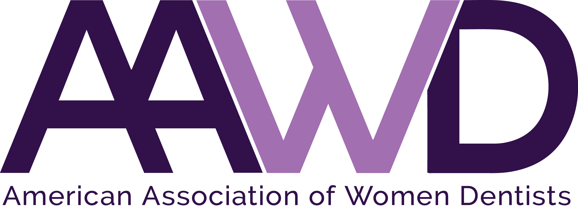

The American Association of Women Dentists presents the Jeanne Hansen Bayless Federal Services Award to recognize the lifetime achievements made by a woman dentist in the Federal Services arena. Application instructions for this award are listed below.

Each year AAWD accepts Federal Services Award nominations for a woman dentist who:
- Has made outstanding achievements in the Federal Services arena as:
  - A civilian dentist [(a dentist who is not currently serving in one of the seven United States uniformed services and who does not qualify for retirement status for a uniformed member from one of those services), such as dental scholarship recipients (programs are generally administered by the National Health Service Corps)],
  - Department of Veterans Affairs dentists,
  - Advocates for federal government dentistry,
  - Civilian dentists involved in federal government clinical assignments, such as Indian Health Services, Bureau of Prisons, U.S. Immigration and Customs Enforcement Health Service Corps, and
  - Dentists who are under the supervision of the U.S. Department of State [nongovernmental organizations (NGOs), such as Doctors Without Borders).
- Exhibits role model qualities that positively reflect the image of women dentists and commitment to the profession.

Nominee eligibility requirements:
- Current AAWD member in good standing and history of full membership in AAWD for at least five (5) years.
- Service as a Federal Service civilian dentist OR acting as an advocate for women Federal Service dental officers (uniformed or non-uniformed dental officers). See above, for examples of Federal government civilian service as a dentist. NOTE: Dentists who have performed some uniformed service, but who do not qualify for a uniformed services retirement can be considered for this award. In other words, a civilian dentist is not to be disqualified for this award for the sole reason of having served some years in a uniformed services capacity.
- Nominee must not have been a member of the AAWD Board of Directors during the past two calendar years.

Nominator must submit the following:
- Application form
- Nominee’s curriculum vitae
- Letter of recommendation on behalf of nominee, explaining reasons for nomination including mentoring and advocacy efforts.
The recipient will be selected by AAWD’s Federal Services representative, and the award will be presented September 28, during AAWD’s Annual Conference in Phoenix, Arizona.

To nominate an AAWD member deserving of this award, complete the nomination form following and return it to the AAWD National Office, along with a recommendation letter detailing why the nominee should be selected, as well as the nominee’s curriculum vitae.

Please forward all nomination materials to the AAWD National Office no later than July 1, 2019.

If you have any questions, please call the AAWD National Office at 1-800-920-2293.

NOTE: These are instructions for the Federal Services Award (Civilian or Non-Uniformed). There is also a Federal Services Award for those who serve in the Uniformed Services, and there is a separate set of instructions for that award. If you have any questions, please call the AAWD National Office at 1-800-920-2293.

AAWD 2019 JEANNE HANSEN BAYLESS
FEDERAL SERVICES AWARD APPLICATION

Please fill out all information completely and legibly.

Nominator’s Name: _____________________________________________________________

Nominator’s Address: ___________________________________________________________

Nominator’s City, State, Zip: _____________________________________________________

Nominator’s Telephone: _________________________________________________________

Nominee’s Name: ______________________________________________________________

Nominee’s Address: ____________________________________________________________

Nominee’s City, State, Zip: ______________________________________________________

Nominee’s Telephone: __________________________________________________________

Nominee’s Email Address: _______________________________________________________

Your completed application should consist of:
- This application form as the first part of your packet.
- Nominator’s typed letter of recommendation explaining reasons for nomination (include information pertaining to nominee’s mentoring and advocacy efforts).
- Nominee’s current CV.

Completed applications must be received by AAWD National Office by July 1, 2019.

Email: awards@aawd.org
Fax: 850-484-8762
Mail: American Association of Women Dentists
National Office
7794 Grow Drive
Pensacola, FL 32514-7072
The Mission of the American Association of Women Dentist:
To be the leading resource for advancing, connecting, and enriching the lives of women dentists.

