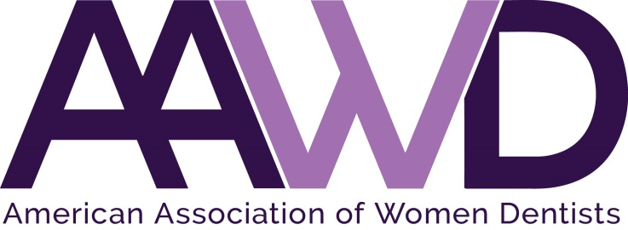

2021 Eleanor J. Bushee Senior Dental Student Awards Nominations Open

The American Association of Women Dentists presents the Eleanor J. Bushee Senior Dental Student Award each year to honor senior dental students who have achieved academic excellence and have demonstrated outstanding leadership. We have attached an Eleanor Bushee Senior Dental Student Award application. Information, guidelines, and the deadline date are listed below.

Dr. Bushee graduated from Northwestern Dental School in 1944. After 15 years in private practice, she entered the academic world. She attained the position of Professor of Pediatric Dentistry and Orthodontics as well as Assistant Dean for Administration at Southern Illinois University of Dental Medicine. Dr. Bushee was an accomplished author and lecturer. She lived her life with verve and style. The recipient of this award should demonstrate enthusiasm in her career in dentistry and in her life as a colleague, friend and mentor.

An advisor or dean may recommend one senior dental from each school to student receive the award. Please allow two to three weeks from the nomination deadline for the certificate to arrive by mail. This award will be accompanied by a one-year complimentary membership in the American Association of Women Dentists.

The deadline for return of materials is March 15, 2021. Please e-mail materials to awards@aawd.org or fax to 850-484-8762.

Thank you in advance for nominating an outstanding senior dental student for this honor and award.

Sincerely,

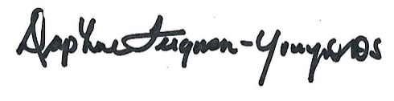
Dr. Daphne Ferguson-Young
AAWD President, 2021

ELEANOR BUSHEE SENIOR DENTAL STUDENT
2021 AWARD APPLICATION

Student Name (as it will appear on the certificate):
School Name:
School Mailing Address:
City, State, Zip:
Submitter Name:
Submitter Email: |  |  |  |  | Phone Number:

(Please note, the certificate will be mailed to the address provided above unless otherwise requested.)
Nominating Advisor/Dean Name:
Reason(s) student is nominated:

2021 AAWD BUSHEE SENIOR DENTAL STUDENT AWARD APPLICATION

Please return no later than March 15, 2021, to:

American Association of Women Dentists
National Office
7794 Grow Drive
Pensacola, FL 32514
Email: awards@aawd.org
Fax: 850-484-8762

If you have any questions, please call 800-920-2293.

Please allow two to three weeks for processing of certificate.

Thank you for your participation in this program.

The Mission of the American Association of Women Dentists:
“To be the leading resource for advancing, connecting,
and enriching the lives of women dentists"

