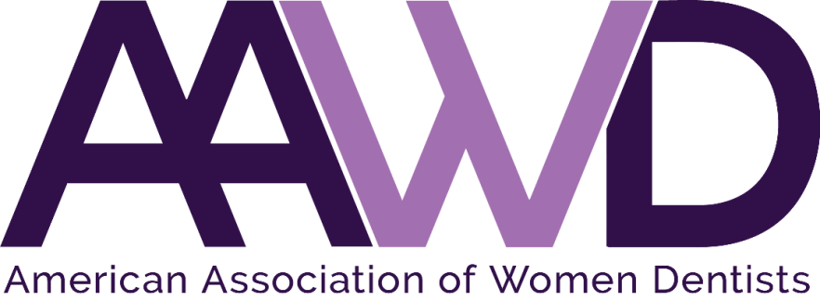

Local Chapter
Starter Guide

What is the purpose of an AAWD Local Chapter?
AAWD is a national organization consisting of thousands of women dentists across the country. For more info on benefits as a national member, visit: https://www.aawd.org/aawd-membership/

We want to foster our national membership values into local chapters. Local chapters enable our national members to have a group of like-minded women dentists available to meet together in person locally in their city or state. Local chapters allow for increased networking, mentorship, and support system amongst women dentists that live in close proximity to each other. We also encourage online involvement of dentists who prefer to be active in local chapter groups in an online setting participating in webinars and utilizing social media groups like Facebook and Skype.

Use the AAWD Membership Directory to get started
If you are interested in leading a local chapter near you, you might already have in mind a few dentists who would be willing to join. You can connect with more dentists in your area through our AAWD Member Directory, which is available to all paid members. This directory lists all AAWD members (dentists and current dental students), organized distinctly by each state; it displays member info such as full name, contact e-mail address, city location, and zip code.
- Login to the AAWD Membership portal here: https://aawd.org/membership
- Click on the “Membership Directory” tab
- Click on the “Search Users” button to pinpoint a member’s name, city, state, or current chapter.
Please note: in order to utilize this directory, you’ll need your AAWD member log in info for the website, if you have forgotten this info, please contact us via e-mail at info@aawd.org.

Host a launch event
Once you have an idea of the number of AAWD members that might be interested in your area, we recommend hosting some form of launch event to cultivate interest in your area. If you need help, the AAWD National Office can help you send out online invitations, or create calendar notifications for your launch event. Members don’t have to pay national dues in order to attend an AAWD launch event for a local chapter.
Please note that after the launch event, any members that join your chapter must pay the national dues for AAWD.

Choose your chapter officers
Simultaneously, we advise getting together a core group of 4 women dentists that can serve as officers for your local chapter to help you lead this initiative. These officers will hold titles of: president, vice-president, treasurer, and secretary. If there are more interested leaders, you can also create additional officer slots such as “Social Chair” or “Service Chair” etc. The name submission of these officers has its own form that needs to be completed and is a requirement in order to be considered an official local chapter under national AAWD.

What are requirements to be a local chapter?
There are four main steps to become an official local chapter with AAWD. Once you notified the AAWD National Office or the Director of Membership of your intent to start a local chapter, you will receive an application packet in order to:
- Submit your chapter officer roster
- Sign the AAWD Confidentiality form
- Write and submit your local chapter bylaws
- Design and submit an estimated 6-month chapter activity plan
To become an official local chapter, you will need a total of 4 active AAWD members. This includes at least 4-chapter officers in the roles of President, Vice-President, Secretary and Treasurer. All officers must be local dentists (non-dentists are not allowed to serve as officers).

How many members do we need to have in order to be a local chapter?
There is no set rule. Local chapters can have as little as 4 members or as many as 50+ members. It’s okay to start out small and gain momentum over the years.

How do we write local chapter bylaws?
The AAWD National office will provide you with a template of chapter bylaws; it’s an easy process of adapting the bylaws for your chapter and filling in the blanks provided by the template. Chapter Bylaws do need to be submitted to the AAWD National Office in order to become a local chapter.

What type of launch event or regular meeting events can we do?
A big part of your chapter’s success is the ability to communicate and support your members. Part of your chapter application process is to create an estimated activity plan for the next six months and identify at least 1 potential sponsor in your area.
Some examples of events could be:
- Wine and cheese events
- Dinner events where you partner with specific restaurants
- Ladies night spa events
- Invite a speaker to present at your meeting about topics relevant to dentistry in general or specific topics related to women in dentistry
- Arrange for CE credits at your sessions
- Mentorship events where your members connect with senior dental students and recently graduated dentists near you
- Volunteer service-related events
- Social events, yoga, or fitness class events.
There is no set rule. You can use your creativity to develop meetings as necessary.

How often do we need to meet as a local chapter?
There is no set rule. Local chapters can meet as often as every month or as little as a few times a year. It’s up to your own discretion as to how involved you want to make your chapter. We do recommend having a regular meeting schedule (once a month or once every other month), however, we don’t have any requirements. We let you govern.

Difference between national dues and chapter dues
All local chapter members must pay national dues to AAWD. We have varying rates for dues for active dentists, faculty, federal service members, retired, students, and recent graduates. You can find more details for membership dues at https://www.aawd.org/aawd-membership/
Local chapters can also set their own dues. It is suggested to charge between $25-50 per person. For local membership dues, you can either charge a certain amount in the beginning for your chapter formation, or if that seems too much then for each specific meeting that you host, you can ask members to pay for their own dinner and other expenses related to that meeting only.

Can male dentists become members?
Yes, male dentists can join a chapter in support of the AAWD. One of the AAWD public policy statements from March 16, 2018 wraps it up the best:
The American Association of Women Dentists both supports and promotes equality and compassion in the workplace, universities, and professional gatherings of any type or size. AAWD upholds a person’s right to work in an environment free of discrimination, harassment, or hostility. This statement can be found in the AAWD Policy and Procedures Manual.

Can international dentists become members?
Yes, they can join as an affiliate member

Can non-dentists become members?
Yes, they can join as affiliate members.

How do we recruit speakers to present at our meetings?
We can help connect you with successful dentists in all regions of the country that have served and contributed to AAWD – you may ask one of those dentists to speak at your event. Besides dentists, you can also bring in other established professionals that aide dentists in their career development. We encourage you to network with dental professionals in your region and ask them to present as speakers at meetings hosted by your local chapter.

How do we connect with sponsors in our area?
There are a number of sponsors that are affiliated with AAWD on a national level. We can help you connect with those sponsors if they are near your area or can provide any sort of online webinar. We encourage you to network and build new connections with dental sponsors in your specific area. It is not a requirement for a local chapter to have any sponsors.

What are the guidelines to creating a bank account?
It is not a requirement for your local chapter to have a bank account. However if a local chapter chooses to have a bank account, a Federal Employer number is required. Use IRS Form SS-4 to apply for this number. The bank account should not be established under an individual’s social security number because that individual would be responsible for paying income tax on the monies in the account. No chapter is allowed to use the name American Association of Women Dentists on their stationery or to open any bank accounts. The association name should read:
“American Association of Women Dentists, _ [Your Location ]____ Chapter.”

How does it benefit me to take a leadership role as a local chapter officer (president, vice-president)?
We celebrate the successes of local chapters and its’ leaders in a variety of ways: write about them in our quarterly newsletter called the AAWD Chronicle, post about them on our national AAWD Facebook page. At our Annual Session Awards Gala (AAWD conference hosted in a different city every year), we have an award for “Local Chapter of the Year” where chapter leaders are recognized, and other awards for dentists who have contributed to the profession and our organization.
As leaders of local chapters, we invite you for an opportunity to have your voice heard and be involved leaders from around the country on our national AAWD Board of Directors through serving on the “Local Chapters Committee” under the AAWD Director of Local Chapters – this is an optional choice for you, it is not a requirement. This outlet also serves as a future potential opportunity for you to network to be selected to serve on national AAWD Board of Directors.

What is the #1 Tip in starting a local chapter?
We want to encourage as many as women dentists as possible to start a local chapter, we want our community to grow. The #1 tip would be that the structure of an AAWD local chapter is flexible enough to be adapted in any way that works for you: the chapter can be as big or small as you would prefer, and the dynamic of the meetings hosted by your chapter can vary greatly. We allow you to grow your local chapter, as you deem necessary.

If you are interested in leading a local chapter in your area, please contact AAWD at the following e-mail address: chapters@aawd.org or call the AAWD National Office at 1-800-920-2293.

